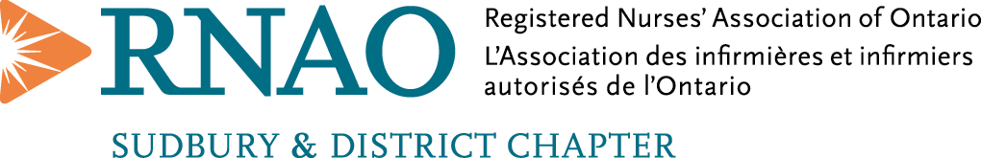

Nomination for Registered Nurses (RN), Nurse Practitioners (NP)
and Retired Nurses (RN)
Nursing Awards 2026

Since May 2008, the Sudbury and District Chapter presents nursing awards during the Nursing Week Celebrations. Please review the criteria and submit a completed application with corresponding rationale for those individuals who you feel should be considered.

Please forward nominations to:

Paul-André Gauthier
Chair of the Nomination Committee
Sudbury & District Chapter.
e-mail to:
rnaoSudbury@gmail.com

Type of awards: (check only one box):
□ –The Nursing Practice award.
□ –The Special Nursing Contribution to our Community award.
□ –The Special Contribution to the Nursing Profession award.
□ –The RN of the Year for the Sudbury Chapter award.
The awards will be presented at an RNAO chapter activity during Nursing Week on Tuesday, May 12th, 2026, and the winner will be featured in our newsletter.

Deadline for the nominations: Friday, April 24th, 2026 before 15:00

Candidate: ________________________
Credentials: ________________________
Title: _________________________
Home Address: ______________________
Workplace (name): ___________________
Work Address: ______________________
Telephone: ____________________
Text number: ____________________
e-mail: ____________________________

Submitted by: ______________________
Title: ______________________
Address: ___________________________
Telephone: ____________________
Text number: ____________________
e-mail: ______________________

