Pauline Daugherty

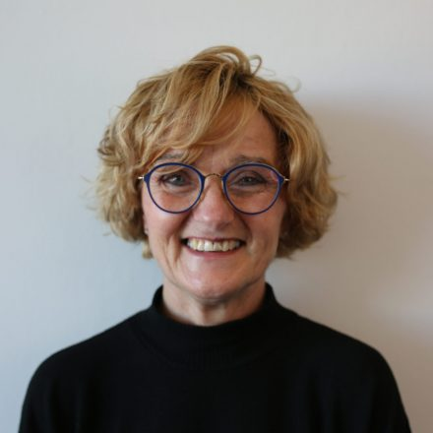

Pauline Daugherty is an RN with over 40 years of nursing experience, having worked across various areas of healthcare, including frontline care, occupational health, and infection prevention and control. Throughout her career, Pauline has developed a deep understanding of the human experience in both health and wellness settings.

As a passionate yoga instructor and an avid follower of positive psychology, Pauline integrates these disciplines into her work, offering a holistic approach to well-being. Her unique blend of healthcare expertise and mindfulness practices enables her to deliver engaging and impactful presentations on positive psychology, resilience, and mental well-being. Pauline is dedicated to empowering individuals and organizations to foster a positive mindset and create environments that nurture personal and professional growth.