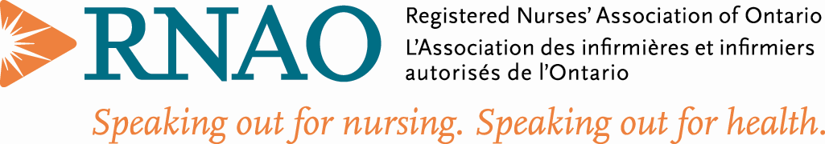
Retired Nurse Interest Group | Dec. 2021
“Wisdom and Resilience - The Retired RN”  Notes from the Chair  Hello and welcome to all our members - hope you are well and safe. We know the pandemic has brought many stresses to our members. It was a time where many returned to work to aid in the ongoing crisis. Many had caregiving responsibilities either for grandchildren or loved ones. Others were faced with an isolation that has brought its own mental health problems however, with some self-care and the availability of vaccines we can hopefully look forward to a better 2022.  Although getting off to a slower start, our executive has met for a planning meeting. We’re looking forward to bringing you some interesting webinars in the new year.  Stay safe. Stay six feet away from those not in your household and wear a mask when indoors (other than at home). We hope that by our AGM in June 2022, we will be able to meet in person!  Marianne - Chair  The executive would like to wish our members a happy and safe festive season as well as a happy and prosperous new year!  Membership:  133 RNs and 933 students as of Sep. 25, 2021, for a total of 1055.  RetNIG is a great investment at only $15/year  During this COVID-19 time, we know that everyone has difficulties - be it financial, caregiving, grandparenting and/or working. Hats off to all the health care workers! We know that many of our members have come out of retirement to aid our healthcare system and for that we thank you!  Reasons to Join RetNig:  - to stay in touch with the issues of the nursing profession today and for those who are retired to give back the wealth of knowledge that we know you all have  - to influence policy changes for the healthcare system  - to provide retirement helpful hints to those who are planning retirement  - to provide mentorship if needed  - to have fun by staying in tune with our nursing family  And for the students, we have a wealth of knowledge in this group if you have a question. If we do not know the answer, I am sure one of us knows someone who does.  Meet our Executive:  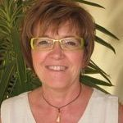  Chair: Marianne Cochrane  Marianne graduated in 1975 with a diploma in nursing, and worked as a clinical nurse for twenty years in the NICU at Lakeridge Health Corporation (formerly Oshawa General Hospital), followed by leadership and management experience (Resource Nurse, Patient Care Facilitator, Clinical Leader and Interim Program Manager) from 1994 through 2001. While working full time, she obtained her bachelor’s degree in administrative studies and master’s degree in health science (nursing).  She completed two terms as a board member of RNAO as Region 8 representative from 2001-2005, and completed terms as president of the Provincial Nurse Educators Interest Group (PNEIG). She has served on various RNAO committees as a chair or member (By-Laws, LAP, Resolutions, Nursing Education, Nursing Practice, Editorial Advisory Committee, two Best Practice Guidelines) and completed 4 years as interest group representative to the board of directors for RNAO from 2012-2016. She is now the chair of RetNIG as of June 2021 after completing her term as ENO of Finance.  She is serving as parliamentarian for RNAO as of June 2021.  She serves on the RNFOO board of directors (2010 to present). Her current role is vice-president of awards and scholarships for RNFOO.  In 2001 Marianne started teaching at Durham College and retired in June 2019 from a full-time faculty member position in the Collaborative BScN Program with the University of Ontario Institute of Technology (newly branded as Ontario Tech University). She was interim co-director from August 2010 to Summer 2011, was year two coordinator from 2011-2015 and then year four coordinator in the program from 2015-2019 when she retired. She is doing semester contracts with Durham College and Ontario Tech U as teaching assistant and lab facilitator in both Practical Nursing and BScN programs; she’s enjoying a few less responsibilities yet contributing to the next nursing generation.  Membership: Betty Oldershaw  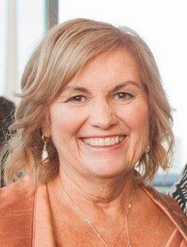  - RNAO BOD Region 1 representative for four years 2016 – 2020  - Chair of Legal Assistance Program for 2 years and committee member for 2 years  - RNAO Chatham Kent chapter president 2012-2016  - Involved in BPSO work at Chatham Kent Health Alliance from introduction to implementing.  - Involved in peer-to-peer initiative for informatics  - Reviewer for Advance Practice initiatives  - Reviewer for Best Practice Guidelines  - Retired Oct 1, 2021  - Clinical Informatics and Transformation Lead - Chatham Kent Health Alliance  - Professional Practice - Corporate - Chatham Kent Health Alliance  - Application Manager - Consolidated Health Information Services  - Emergency Clinical Manager / Sexual Assault / Domestic Violence - Chatham Kent Health Alliance  - Grasp Co-Ordinator - Chatham Kent Health Alliance  Finance: Brenda Hutton  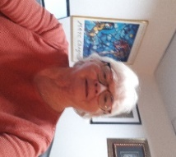  I live in London, Ontario. I retired recently after 50 years in the nursing profession. I have worked in acute care, nursing education, home care and mental health. Fortunately, I will remain connected to my profession through RNAO. I have two children and five grandchildren who live in the city, and I am quite involved in their lives.  My interests include reading, walking, travelling, circle dancing, choir, the arts and continued learning. I enjoy visiting with friends and spending time by water. I am hoping to walk the Camino and visit Norway and Iceland with my grandson when travel is possible.  I am looking forward to retirement and hoping to have more space and mindfulness in my life and have time to "smell the roses"  Communications: Una Ferguson  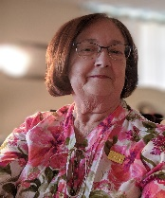  I retired in Dec. 2020 and have three adult children and four delightful granddaughters. I have recently completed a graphic design course and have redesigned the SNIG website. I sing in a choir and love yoga and other self-care methods to keep me healthy.  Politically I speak out for accessible affordable housing, and improvement in LTC to make sure there is appropriate staffing and the right mix of staff to take care of the residents.  Communication:  RetNig has been busy as we learn the art of communication in the digital age.  We are now active on Facebook, Twitter, and Instagram and have been busy using and learning our own Zoom Account.  Communication with our members is especially important. Please let us know how you would like us to communicate with you.  You can contact us through our website or at  retnig.rnao@gmail.com  This year has been an unusual one for sure! Hopefully, we will see brighter times ahead.  Stay tuned as we develop our website and keep you informed of upcoming events!  Political Action: Althea Stewart  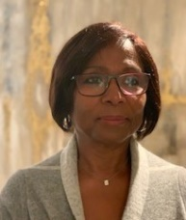  So now I am retired…what does that mean to me? Firstly, NO futile commuting and racing against time, traffic and weather to get to a physical space to use a computer. I now have free time to relax, pick, choose and refuse activities. I have been blessed with a beautiful granddaughter, and an additional focus of love. I think I appreciate my garden more and the lovely backyard we are fortunate to have. I am exercising about the same, this typically involves a 60-minute slow jog four times a week. I have tried yoga, but it has not stuck with me… I keep trying. I have switched to a mostly vegan menu…well maybe about 3 times per week.  COVID-19 certainly interrupted the plans I had for travel and socializing. However, I find opportunities and approaches to meet with my friends and family outdoors, and wine is not as important to me as it used to be.  Professionally, I am now a part-time professor, teaching “Leadership and Evidenced Based Practice” (EBP) at Conestoga College. I find it very rewarding to share my knowledge of EBP with healthcare students. Many of them are nurses and pharmacists who have relocated to Canada and are taking courses towards their Canadian designation in their profession. I also continue to volunteer some time with RNAO through the Retired Nurses Interest group and supporting the team working on best practices at the University Hospital of West Indies. I am mentoring a RN who is studying to become an NP, while I do not have that designation, she found in me the support and experience that helps to guide her.  Retirement requires a personal approach to satisfy your own goals, be those self-care, volunteering or travel. So far, it’s been wonderful, and I look forward to new adventures. I am truly thankful to God for my health, my family, friends and all the blessings I have.  Social Media: Adrienne Knappes  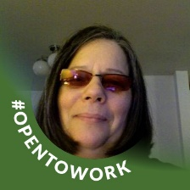  Worked in the medical arena as a Registered Nurse. Worked in the Intensive care, Operating Room, Emergency and Complex Care. Advancement in Management, designing medical programs, policies, developing government health programs, bylaws, applying for grants and government funding. Entrepreneur startup for three businesses.  Board Representative for Algoma Chapter of RNAO.  A Final Word  Please remember to follow us on Facebook and Twitter. Our social media information can be found below:  http:/ /rnao.ca/connect/interest-groups/retired-nurses-interest-group-retnig | 