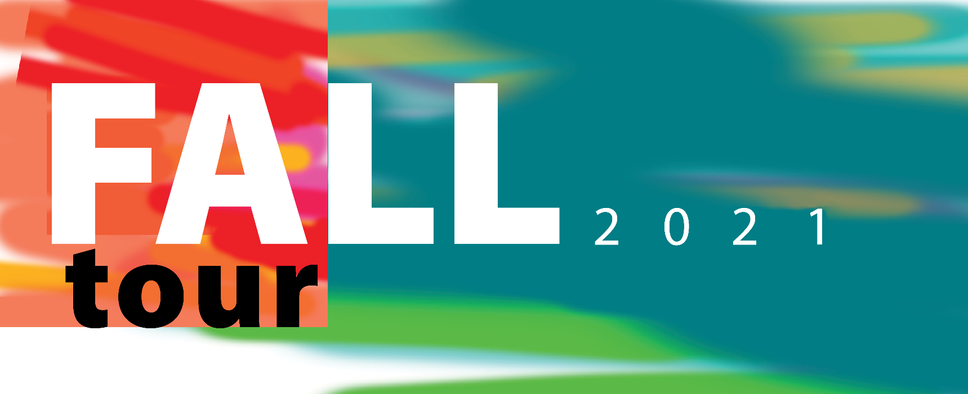­

**https://myrnao.ca/civicrm/event/info?reset=1&id=1155**

**FALL TOUR - HAMILTON**

**VIRTUAL EVENT**

Zoom Meeting

**NOVEMBER 18, 2021**

6:00PM TO 8:OOPM

**HOSTED BY RNAO HAMILTON CHAPTER**

Key Note Speaker: Morgan Hoffarth, RNAO President

Register here:

**[HAMILTON](http://chapters-igs.rnao.ca/chapter/44/about" \o "Muskoka-Huronia-Parry Sound Chapter website" \t "_blank)**

[CHAPTER](http://chapters-igs.rnao.ca/chapter/44/about" \o "Muskoka-Huronia-Parry Sound Chapter website" \t "_blank)