MHNIG Geriatric Addiction Series: Opioid Use in Older Adults
With Zena Samaan

Please join us for the final in a four-part series discussing opioid use and older adults. This area of research is notoriously under evaluated, unaddressed and will become much more common as Canada’s population ages. Dr. Samaan, is a physician researcher, her clinical and research emphasis is on mood disorders and addiction comorbidities.

Objectives:
- Provide an overview of the opioid crisis
- Summary of the management of opioid use disorder in older adults

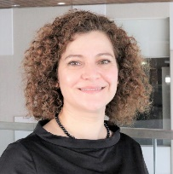
Dr. Zena Samaan is a Professor of Psychiatry and Director of the Clinician Investigator Program, Faculty of Health Sciences, McMaster University.

When: October 13th, 2021, at 6 PM Eastern Time
By Zoom Webinar
Please register here:
https://myrnao.ca/civicrm/event/info?reset=1&id=1144
****Space is limited so register early****

