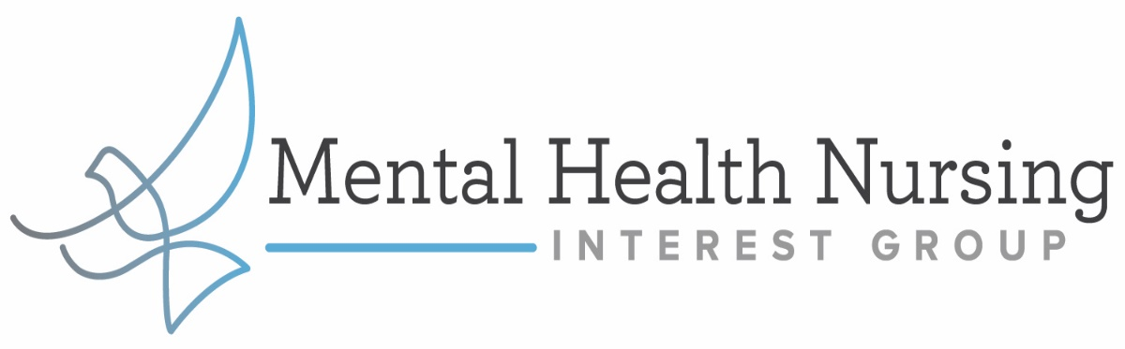

Canadian Federation of Mental Health Nurses 2021 Conference Grant
As you may know, the CFMHN Biannual conference is fast approaching. As members of MHNIG, we would like to support 5 people in attending this amazing conference.
To do so, the first 5 MHNIG Members who respond to this email will receive 200 dollars towards the cost of attending. Send your Email with the heading “CFMHN Grant” to: mentalhealthnursingrnao@gmail.com

Please note that you must provide your RNAO membership number and your full name in the email to verify that you are a MHNIG Member. Also once chosen, you will also be asked to provide proof of registration before you receive the funds.
We look forward to hearing from you, but only winning members will be contacted.

MHNIG Executive

