MHNIG Geriatric Addiction Series: Benzodiazepines Use Disorder in Older Adults With Dr. David Conn

Please join us for the third in a four-part series discussing substance use and older adults. This area of research is notoriously under evaluated, unaddressed and will become much more common as Canada’s population ages. Dr. David Conn, a leading educator and clinical specialist in this area, will share his expertise and research on this emerging topic.

Objectives:

- Outline the use of benzodiazepines in clinical practice
- Provide an overview of Substance Use Disorders among older adults
- Describe the key recommendations on Benzodiazepines Use Disorder

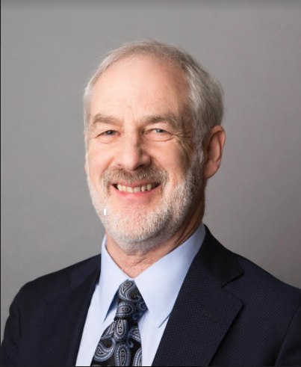
Dr. David Conn is the Vice President of Education at Baycrest, a Professor in the Department of Psychiatry at University of Toronto and is the Co-Chair at the Canadian Coalition for Seniors’ Mental Health

When: June 15th, 2021 7PM Eastern Time
By Zoom Webinar
Please register here:
https://myrnao.ca/civicrm/event/info?reset=1&id=1084
****Space is limited so register early****

