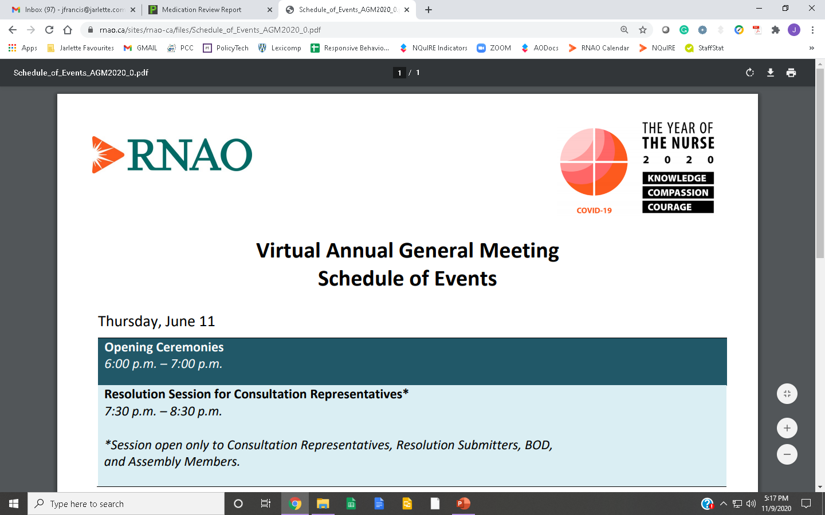

**National Nursing Week**

**May 10-16, 2021**

**l**

Chatham-Kent Chapter

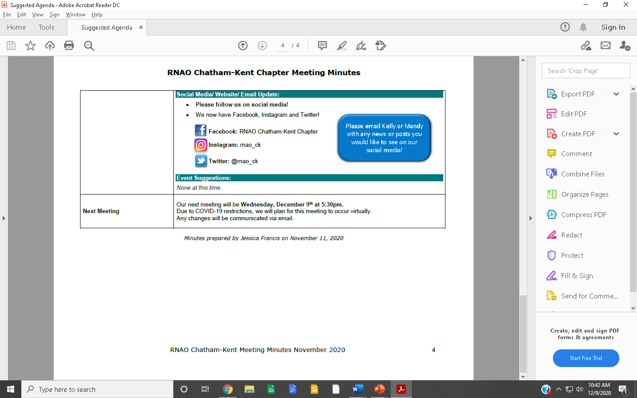

- this document with questions answered   
- a photo of you   
- any additional photos you wish to   
 include of yourself or your work  
- your social media information if you   
 wish to be tagged

- (*optional*) video(s) of yourself answering   
 the questions – max 1 minute / video

**Member Name:**

**Place/sector of current employment:**

**Member Profiles**

**In preparation for   
*National Nursing Week,*   
the Chatham-Kent Chapter is looking to feature member profiles on our social media**!

This is a great opportunity for members to get to know each other and learn about the great work everyone is doing!

**Please submit the following to the email address below:**  
*Please ensure you have permission   
to use any photos you submit.*

[**RNAOChathamKent@gmail.com**](mailto:RNAOChathamKent@gmail.com)

***May use additional page for answers if required***

**1. Tell us about yourself – your nursing specialty, education,   
 career path, future aspirations, etc.**

**2. Why did you join RNAO?   
 How has RNAO influenced your nursing career?**

**3. Why did you join RNAO?   
 How has RNAO influenced your nursing career?**

**4. What advice do you have for nursing students?**

**5. What is your nursing philosophy?   
 What values are important to you as a nurse?**

**6. Tell us about yourself outside of your nursing career.**

**FOLLOW US ON SOCIAL MEDIA!**

**Member Photo**

*.*

**Additional Page:**

**Member Name:**