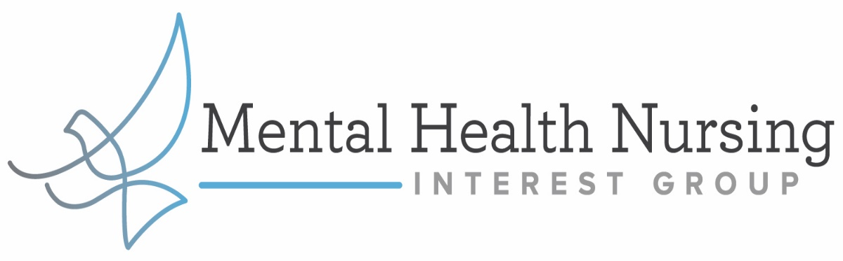
MHNIG Geriatric Addiction Series: Alcohol Use in Older Adults
With Marilyn White-Campbell

Please join us for the first in a four-part series discussing substance use and older adults. This area of research is notoriously under evaluated, unaddressed and will become much more common as Canada’s population ages. Marylin White Campbell, a leading researcher and clinical specialist in this area, will share her expertise and research on this fascinating topic.

Objectives:
- Discuss the risks of alcohol use in older adults.
- Use of harm reduction strategies for older adults.
- Apply the Canadian Guidelines on alcohol use disorder among older adults.
- Assessments that can be used in a geriatric population.

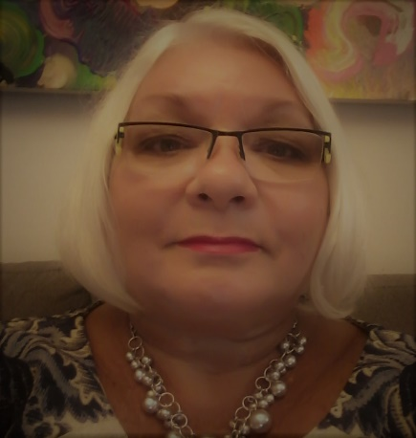
Marilyn White-Campbell is a Clinical Geriatric Addictions Specialist with Baycrest Long Term Care Behavioral Support Outreach teams.

When: April 26, 2021 630 PM Eastern Time
By Zoom Webinar
Please register here:
https://myrnao.ca/civicrm/event/info?reset=1&id=1022
****Space is limited so register early****

