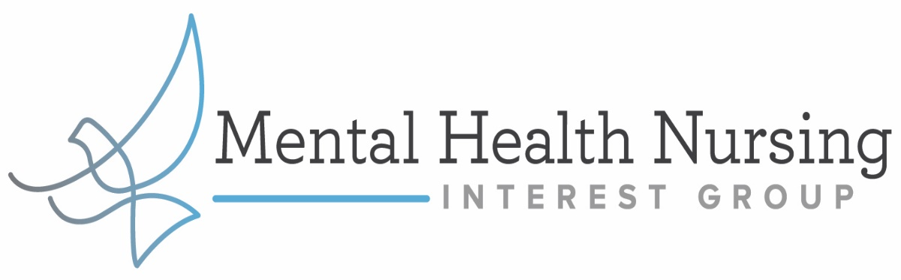
BounceBack: A Free Mental Health Program to Help your Clients Manage COVID-19 Related Anxieties, and More, from Home
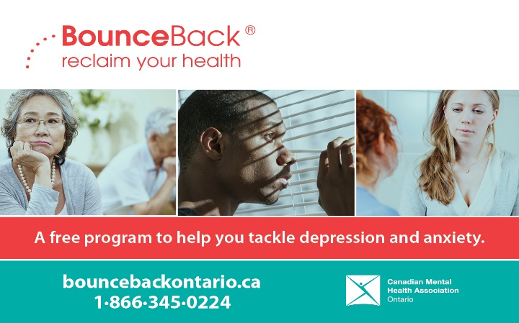
We invite you to a presentation about BounceBack, a free skill-building program grounded in cognitive behavioral therapy designed to help individuals 15+ manage low mood, mild to moderate depression and anxiety, stress or worry. Whether your patients' symptoms have been brought on by the COVID-19 pandemic or other life stressors, BounceBack can help!

This information session will provide an overview to the BounceBack program as well as provide insight into:
- New client resources (for new parents, youth 15-18, caregivers, and individuals experiencing chronic pain)
- Real life examples of BounceBack participants
- How to refer
- Top frequently asked questions
- COVID-19 Client profile

Speaker Bio: Angele D’Alessio is a bilingual stakeholder engagement coordinator, BouceBack since 2019 and a mental health promoter with CMHA Champlain east since 2006. Her primary role is to promote, initiate, coordinate and present mental health education designed to improve attitudes towards mental illness and promote mental health and well-being. Her educational background includes Diploma of Social Service Worker, Train the Trainer certification, Working with Dementia Clients certificate, Mental Health Works Certification, Mental Health First Aid contract trainer and safeTALK trainer for suicide prevention.

When: Feb 22, 2021 05:15 PM Eastern Time
By Zoom Webinar
Please register here:
https://myrnao.ca/civicrm/event/info?reset=1&id=983

