STRENGTHENING SELF-CARE AND RESILIENCY
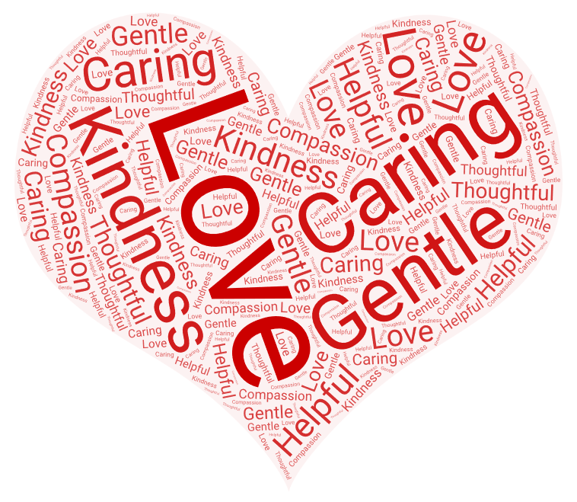
THIS VALENTINE’S MONTH, LET MIDDLESEX-ELGIN CHAPTER TREAT YOU TO A LITTLE R&R (RELAXATION & RESTORATION)
SIGN UP TO PARTICIPATE IN OUR SELF-CARE WEBINAR SERIES
“SHARE THE LOVE”

Wednesday, February 17, 2021 7:30 – 8:30 pm
Share the love: Our Pandemic Experience and What the Science of Positive Psychology has to Offer. Facilitator: Cathy Parsons
Register: https://myrnao.ca/civicrm/event/info?reset=1&id=971

Wednesday, February 24, 2021 7:30 – 8:30 pm
Share the love: Igniting the Spirit through Song & Drum
Facilitator: Katrina Graham
Register: https://myrnao.ca/civicrm/event/info?reset=1&id=972

Wednesday, March 3, 2021 7:30 – 8:30 pm
Share the love: Daily Grounding and Heart-to-Heart Meditation.
Facilitator: Farnaz Michalski
Register: https://myrnao.ca/civicrm/event/info?reset=1&id=973

To learn more about these exciting events please go to https://myrnao.ca/sites/default/files/attached_files/Descriptions%20of%20Presentations.pdf

