Retired Nurse Interest Group | October 2020
“Wisdom and Resilience- The Retired RN”  Notes from the Chair  Hello to all our members- hope you are well and safe. Our last Newsletter was in March and then the pandemic hit full force. Interestingly for an Interest Group based on "retired nurses", so many of our members went back to work to help during the pandemic!!  As a result of this we have a few changes in our RetNIG executive.  Irmajean Bajnok, our Chair, had to step down as she is working in the Political Action Department at RNAO and so cannot be part of any executive (Chapter or Interest Group). I have been taking on the activities of Chair in the interim. As well, Suman Iqbal, our Communication ENO also had to step down from her position as she is providing full time support to several LTC facilities.  We will be posting a call for nominations for both executive positions.  On a positive note Althea Stewart has been elected to the position of Policy and Political Action ENO for RetNIG. Welcome Althea and we are SOOOO excited to work with you going forward.  Stay safe. Stay 6-feet away from those not in your household and wear a mask when indoors (other than at home). We hope that by our AGM in June 2021, we will be able to meet in person!!  Rhonda Seidman-Carlson Past Chair  EVENTS:  We will be hosting 3-4 Webinars for our members between now and June 2021. On October 27th Mr. Alan Direnfeld will be speaking about Estate Planning, Wills and Executors. I have heard him speak and learned so much - resulting in some changes in how we are managing our estate for the future. Please join us.  Register now: https://myrnao.ca/civicrm/event/info?reset=1&id=896  We will be having the College of Nurses repeat their extremely popular "Are you practicing Nursing?" webinar- Date TBD.  In addition, we have reached out to Veronique Boscart about speaking on "The Impact of the Pandemic on Aging Families"  Membership:  104 RN’s as of Sept 25, 2020 and 597 Students for a total of 701.  RetNIG is a great investment at only $15/year  For Students RetNIG has a lot of experience for you to draw on. If you have a question, please ask!  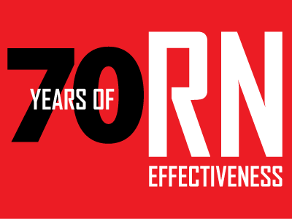  Policy and Political Action:  Queen's Park on the Road 2019  Queen's Park on the Road (QPOR) is an exciting annual event that enables RNAO Members to meet their MPPs within their local constituency office to discuss key nursing, health, and health-care delivery issues. Starting on October to December 2019, RetNIG members from Waterloo, Peel and Durham participated on the event and engaged with their local MPPs discussing two critical nursing and health priorities: A better approach to long-term care in Ontario; and the accidental opioid overdose crisis. Th e same issues will be brought up at the Queen’s Park Day on February 20, 2020.  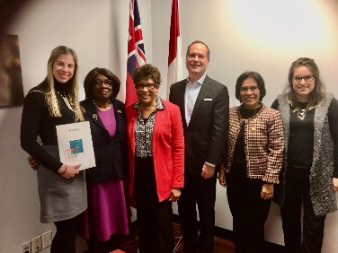 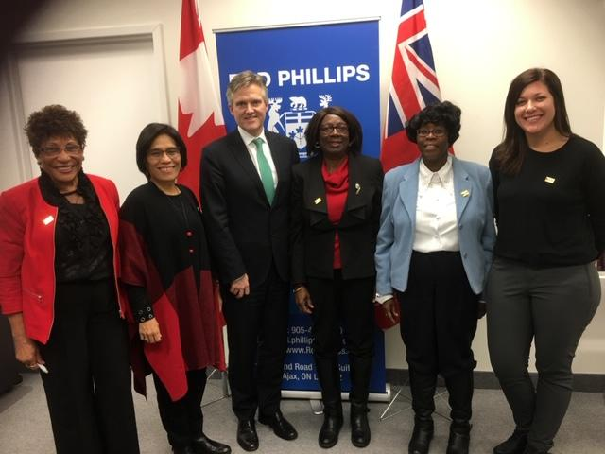  RetNIG PPAN Officer, Betsy Jackson with Durham chapter members during QPOR with MPP Peter Pethlenfalvy (left)  MPP Rod Phillips ( middle) & MPPLindsey Park (right)  Queen's Park Day 2020  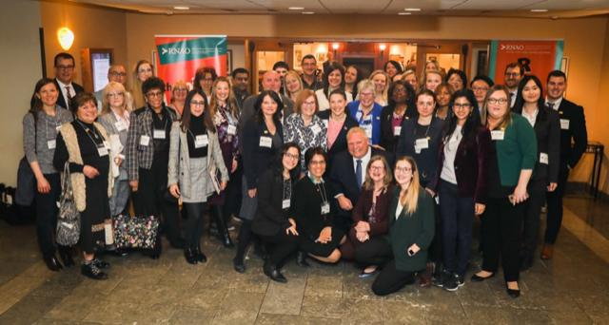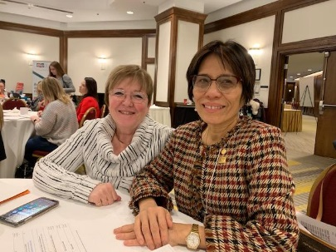  On February 20, 2020, more than 130 RN, NP and nursing students met and engaged with the politicians at Queen’s Park for breakfast. RNAO members from their chapters and interest groups sat with their local MPPs pressing for urgent action on the opioid crisis, an epidemic that shows no slowing down. Across Ontario, five people lose their lives each day on the streets and in the dormitories due to accidental overdose. Ontario has a slow response for consumption and treatment services. Every community in need should get a site to respond to this devastating crisis.  The Long-Term Care homes staffing levels were also discussed. Currently the staffing ratio in Ontario is 71%PSW, 18%RPN and 11%RN &NP. With the resident’s current health complexity such as multiple chronic conditions, cognitive impairment & behavioural symptoms, a new funding model is recommended to properly meet and address such complex needs. RNAO’s recommendation for staffing ratio is 55% PSWs, 25% RPNs & 20% RNs &NPs.  Aside from the several MPPs, Premier Dough Ford and Health Minister & Deputy Minister Christine Elliott came to give greetings.  After the breakfast meeting, several members were able to listen and observe the Question Period The afternoon, was a very informative and engaging time to listen and ask questions from the different parties-Minister of Health Christine Elliott; France Gelinas, MPP, Nickle Belt, Ontario New Democratic Party Critic- Health Care; John Fraser, Ontario Liberal Party and Mike Schreiner, Leader, Ontario Green Party. The Ontario Chief Nursing Officer, Michelle Acorn was also in attendance and gave greetings.  Communications and Policy & Political Network Officer Assembly  On February21, 2020, was another full day meeting which included reports from the RNAO President, CEO report, QPD, the day after and what’s next, Proposed Bylaw Changes discussion, Members’ Voices sharing, update from the Government on Ontario Health Teams by Phil Graham, Executive Lead, Ontario Health teams Division and lastly, Matthew Kellway, Director Policy presented the plans for modernising the Policy & Political Action onRNAO.ca. The new Policy and Political Action page will launch in June AGM.  Three members of RetNIG were present at Queen’s Park Day, Marianne Cochrane, and Una Ferguson & Betsy Jackson.  No Political Action events happened from March till now except for signing up for the Action Alerts sent by the RNAO office.  Finances:  It is a pleasure to report as of Aug 31/20, RetNIG account balance is $3,605.12. With the new membership year beginning Nov.1/20, we will receive in February 2021 membership fees once determined. Our monthly bank plan expense is $5.00 each month maintaining our account.  Given the Covid-19 issues, we have not had any expenses over the past months.  A sincere thanks for continuing your membership or having joined our Interest Group this year.  A Final Word  Please remember to follow us on Facebook and Twitter. Our social media information can be found below:  http:/ /rnao.ca/connect/interest-groups/retired-nurses-interest-group-retnig | “Retirement is a blank sheet of paper. It is a chance to redesign your life into something new and different.”  Patrick Foley, Winning at Retirement

