View this email in your browser: https://us6.campaign-archive.com/?e=&u=a2c23a25eee9031190b45c841&id=9b90cdebc1
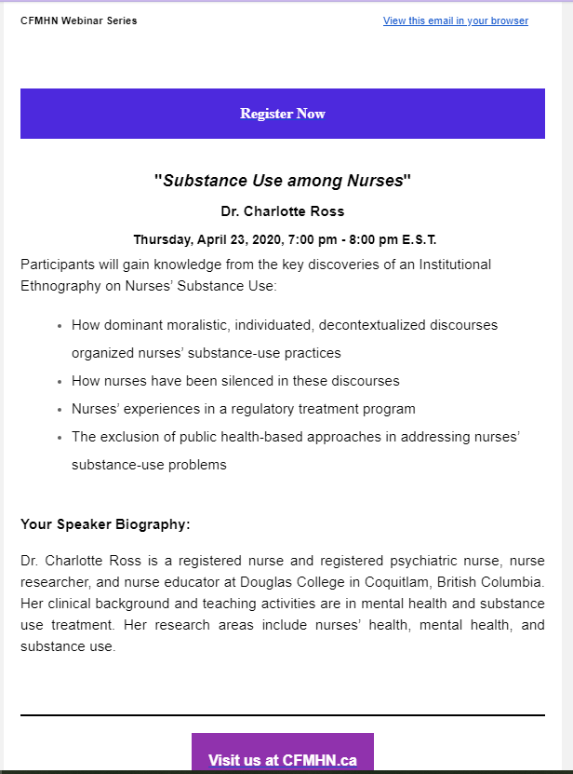

Register Now: https://www.cfmhn.ca/event_calendar/#id=115&cid=1590&wid=601

