Please join us for a free educational session hosted by RNAO Middlesex Elgin and the Legal Assistance Program:
Understanding Violence and Harassment in the Workplace
Date | Tuesday, April 23th 2019
Time | 7:00 – 8:30 pm
Location | Parkwood Institute – Main Building  Room B2-109: Auditorium  550 Wellington Road, London, ON, N6C 0A7
Cost | Free | Parking: $4 on site
RSVP deadline | April 19th 2019
Non-members are also welcome at no cost.

Please go to the following link to register:
https://myrnao.ca/civicrm/event/info?reset=1&id=589

Map of Parkwood Institute
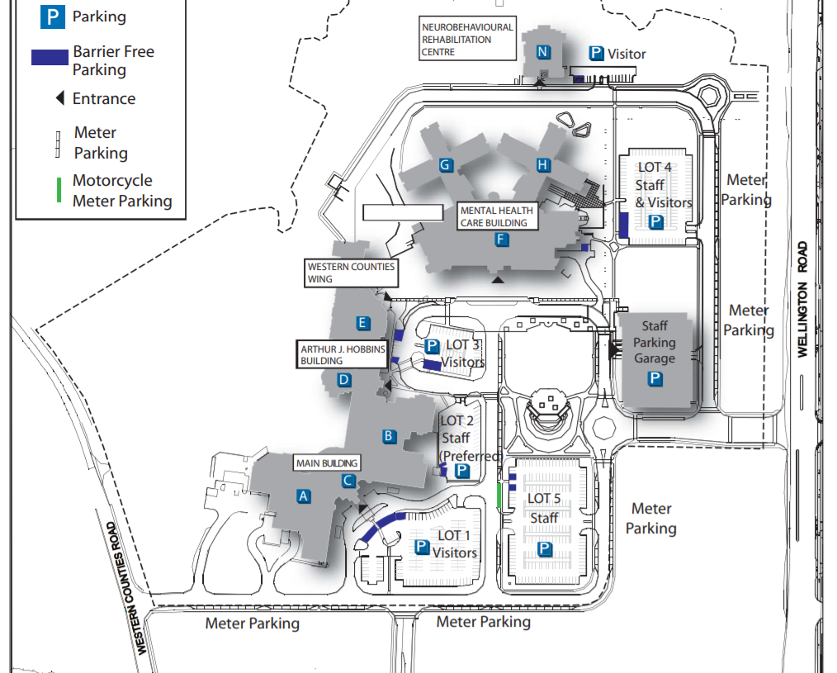
Auditorium B2-109

