****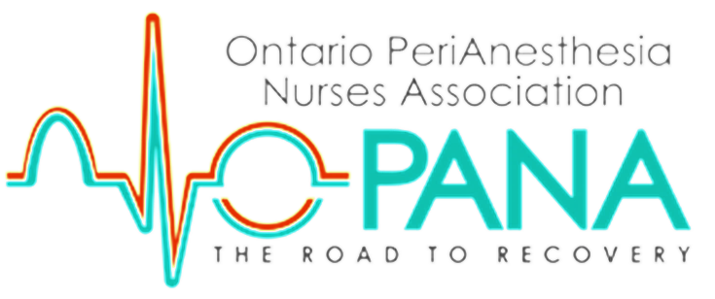



“THE FUTURE BELONGS TO THOSE WHO PREPARE FOR IT TODAY”

-MALCOLM X

**YOU ARE INVITED TO OUR 2018 PERIANESTHESIA NURSING CONFERENCE**



OCTOBER 20-21, 2018 | MARRIOTT ON THE FALLS | NIAGARA FALLS

AGENDA OF DYNAMIC TOPICS

* **The Journey of Pediatric Dentistry: Past, Present and Future**
* **Marijuana & Pain**
* **Compassion Fatigue, recharge your batteries!**
* **Synergy: The Right Nurse for the Right Patient and Patient Acuity**
* **Smoking Cessation**
* **Mechanical Thrombectomy: Time is brain!**
* **MAID & Trillium Gift of Life**
* **The role of the RPN in PeriAnesthesia Nursing**
* **Public Health & Flu Season: what**

**is new?**

* **Group Networking Sessions:**

**Current Issues & Trends in Peri-Anesthesia Nursing**

* **Ambulatory Total Knee Replacement Surgery**
* **The Use of Ketamine: Craniotomy**
* **Providing Culturally & Clinically Competent Care to LGBTQ+ Patients**
* **Innovation and Technology in Education**
* **Narcotic Diversion**

# **Join in on ADDED fun with a Silent auction, Networking, Exhibitors & Zumba!!!**

TO REGISTER ONLINE VISIT <http://www.opana.org/conference>

Z



