Experiential Hearing Voices Workshop
Hearing Voices that are Distressing Experience:
Schizophrenia is a brain disease and one of the most serious mental illnesses in Canada. Common symptoms are mixed-up thoughts, delusions (false or irrational beliefs), hallucinations (seeing or hearing things that do not exist) and bizarre behaviour. People suffering from schizophrenia have difficulty performing tasks that require abstract memory and sustained attention. https://www.canada.ca/en/public-health/services/reports-publications/report-on-mental-illnesses-canada/schizophrenia.html
“Hearing Voices workshop is a ground breaking training that helps mental health professionals understand the challenges that face people with psychiatric disabilities. Participants listen to distressing voices through headphones while completing a series of tasks. Afterwards, during the debriefing, even veteran practitioners say that they have gleaned new insights into the strength and resilience of those of us with psychiatric disabilities”. Patricia Deegan

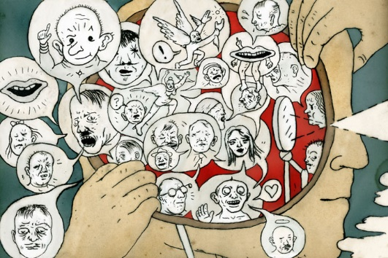

This workshop provides an experience of what is commonly called “auditory hallucinations” and is a tremendous learning opportunity for all nurses, nursing students and health care providers regardless of their area of speciality and place of practice.

Not only will participants experience a simulation of auditory hallucinations, they will gain a new appreciation of the challenges some people face, their resiliency and strength. Participants will also be learn how to work with the person who hears voices as well as receive information on community support services.

Note: This workshop is NOT for the person who hears voices

October 20, 2018 @ 0930
Seminar Room 3: Charles & Margaret Juravinski Hospital (West 5th & Fennel Ave)
St. Joseph’s Healthcare Hamilton

Pre-registration is required

