[f.png](https://twitter.com/RNAO_Lambton)[f.png](https://www.facebook.com/groups/349077205111690/?ref=bookmarks)­

LAMBTON CHAPTER

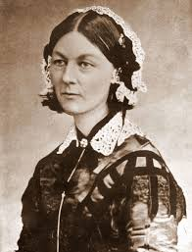

Meet Members of the Local RNAO and enter your name in for a draw!

This is an annual event that is made possible by the kind and

generous support of the Coffee Lodge Canada

We thank you from the bottom of our nursing hearts!!!

Organized by your local chapter of the Sarnia-Lambton RNAO!

**Raise a cup to Florence Nightingale – founder of Modern Nursing!!**

*ALL NURSES INVITED*

Thursday May 10th, 2018

Drop in to the Coffee Lodge Canada – 400 Exmouth St.

8 am to 6 pm

Receive a free cup of tea or coffee!

Door prizes

**RNAO.ca**

May 7-13

Nursing Week 2018

RNAO: POWERING NURSING to ADVANCE HEALTH