

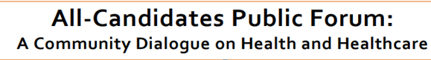



Fogolar Furlan Club, Windsor Hall

1800 N. Service Rd., Windsor, ON N8W 1Y3

Wednesday, May 16th, 2018

7am to 9am

**Get Involved!**

Every Windsor-Essex County resident is encouraged to attend this important forum. All local Candidates from all ridings have been invited to participate.

**Get Informed!**

Health and healthcare are important issues to Canadians and our provincial government has a vital role to play in keeping Canadians healthy. Attend to ask questions and find out where our local candidates and their parties stand on important health issues.

**Get Voting!** Make an informed choice. You have a right to vote so use it and make it count.

Light refreshments will be served.

Kindly RSVP to windsoressexrnao@gmail.com or 519-551-1545

by May 11, 2018